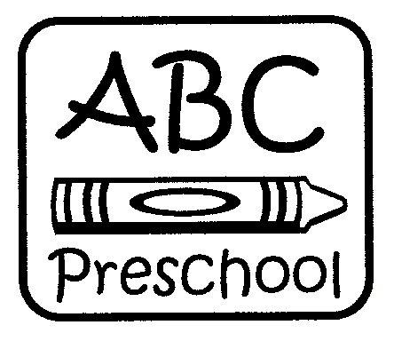
ABC Preschool of Arbor Baptist Church
Registration Form 2025-26
ABC Preschool registration is done on a first come, first serve basis.
Openings are limited. If classes are full, your child will be placed on a waiting list.

Requirements for Registration:
- Two completed forms: This Registration Form and Student Information Sheet (attached)
- Registration Fee: $80.00 (non-refundable) for the first child and $40.00 per each additional sibling.
- Supply Fee: $130.00 (non-refundable) for each child, due by Friday, May 16, 2025. If you are enrolling after this date, then the total of both fees is due to make your child’s enrollment official.
- State of Virginia School Entrance Health Form, completed within the last year, due the first week of school.
- Student’s original birth certificate (if not currently enrolled). We will make a photocopy here.

DISCLAIMER: ABC Preschool will gladly seek input from parents to meet the needs of a child whenever possible; however, ABC Preschool reserves the right to refuse enrollment to any child, or withdraw any student after enrollment, if the ABC Preschool Board determines that the preschool does not have the resources available to meet the needs of the child. (See Parent Handbook.)

Child’s Name: Date of Birth: / / __

Check below which class your child is eligible to attend. Children must be the required age for each classroom by September 30, 2025.
____ New Adventures Class* (2-year-olds): Mon/Wed/Fri, 8:30am-noon
____ New Adventures Class* (2-year-olds ONLY) 2-day flex option: 8:30am-noon
____ Intermediate Class (3-year-olds): Mon/Wed/Fri 8:30am-noon
____ Junior Kindergarten Class (4-year-olds): Mon/Wed/Fri, 8:30am-noon

Prices: Three-day programs: $2,115.00 per year, payable in monthly installments of $235.00
Two-day program: $1,485.00, payable in monthly installments of $165.00
*$30.00 fee per month for 2-year-olds only who are not toilet trained (to be re-assessed quarterly)
All students who are 3 years old and up at the beginning of the school year must be toilet trained.
There is a 10% discount for each additional sibling enrolled.

Please list the best email address to provide updates and reminders (for ABC Preschool use only):
Email Address: ________ Contact Name: __

How did you hear about our program? __

Are you interested in a church official contacting you with information about Arbor Baptist Church and its programs? Yes No

Office Use: Date _________________
Registration Fee _____ ck# _______ cash _____ rcpt. issued_____
Supply Fee ____ ck# _______ cash _____ rcpt. issued _____
Tuition ____ Month ____ Year ___ ck# _______ cash _____ rcpt. issued _____

ABC Preschool Student Information & Emergency Medical Authorization

Child’s Full Name: Birthdate: / /
Mother’s/Guardian’s Full Name: ______
Physical Address: __________Zip Code: ______________
Mailing Address (if different):_________________________________________________________________________
Primary Contact Phone: ______________________(Cell/Home) Alternate/Business Phone: ________________________
Occupation: ________________________Business Address:
Father’s/Guardian’s Full Name: ______
Primary Contact Phone: ___(Cell/Home) Alternate/Business Phone: _______________________
Home Address (if different): ____________
Occupation: ________________________Business Address:
Emergency Contact Name: Emergency Contact Number:
(This person will be contacted if parents do not answer our call.) Relationship to student: _________________________
Please list everyone authorized to pick up your child:
__________________________________________________________________________________________________
__________________________________________________________________________________________________
Please list anyone not authorized to pick up your child:
Primary Doctor: Phone #:
Specialist: Phone #:
Dentist: Phone#:
Medication and Dosage:

Allergies:
Preferred Hospital in case of medical emergency:
Does your child have any special requirements, special needs, or delays that have been diagnosed by a pediatrician or other professional? Yes No If “Yes”, please explain:
List any other helpful information we should know about your child: ______
EMERGENCY MEDICAL AUTHORIZATION: 2025-26 School Year
I authorize ABC Preschool to seek emergency medical care for my child in the event of a medical emergency. (ABC Preschool will contact parents as soon as possible after contacting emergency services.)
I understand that I am responsible for any costs of such treatment through my own medical insurance.

Parent Signature: Date:

